UNIT 8
Advanced Neural Network
8.1 Transfer Learning
8.2 Attention Mechanisms in CNNs
8.3 Practical Applications of CNNs

8.1 Transfer Learning
https://neptune.ai/blog/transfer-learning-guide-examples-for-images-and-text-in-keras
https://medium.com/@PriyankaKumari25102002/mastering-transfer-learning-in-computer-vision-unleashing-the-power-of-pre-trained-models-3593102b278d
Transfer learning is a machine learning technique where a model trained on one task is reused for a new, related task. It is especially popular in deep learning, where training models from scratch requires vast amounts of data and computational power. Transfer learning helps mitigate the challenges of limited data and resources by leveraging pre-trained models and adapting them to new problems.

1. What is Transfer Learning?
Transfer learning is the process of taking a model that has been trained on one task (source task) and reusing it on another task (target task). In this approach, the knowledge gained from a previous task is applied to improve the performance of a model on a different but related task. The primary goal of transfer learning is to reuse the weights learned by the model during its initial training on a large dataset, so that it can apply those features to new tasks with smaller datasets.
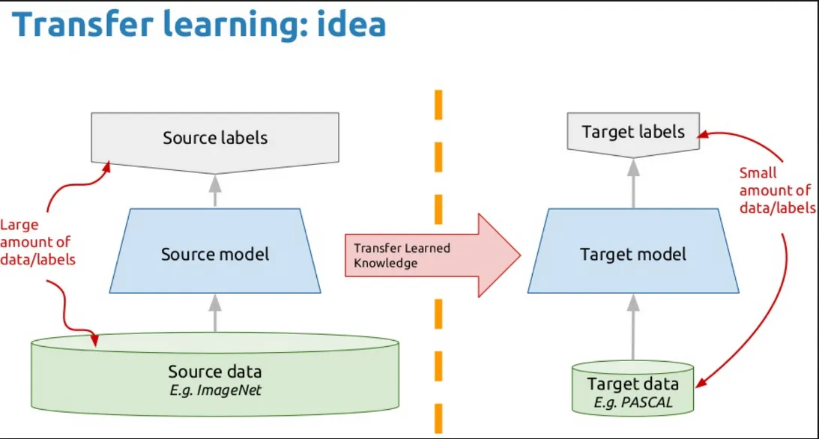
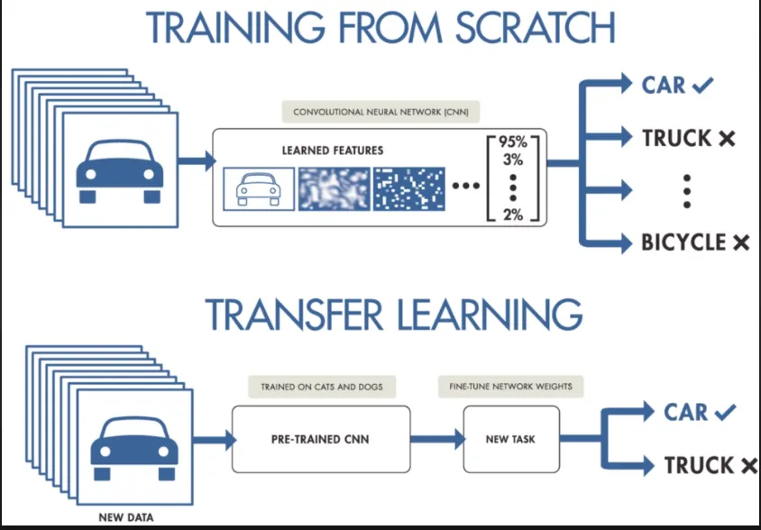

Example:
- A model trained to recognize various objects in images (e.g., animals, vehicles) can be reused to classify a new object, like food or drinks, with fewer examples in the new dataset. The model doesn't need to start from scratch but leverages its previous learning of general image features like shapes and edges.

2. How Transfer Learning Works
In deep learning, neural networks learn hierarchical patterns across multiple layers. Early layers of the network typically learn basic features like edges and textures, while deeper layers learn more complex features such as shapes or specific object parts. In transfer learning, we typically use the early and middle layers from the pre-trained model, as they capture general features that are useful for a variety of tasks.

Types of Layers:
- Frozen Layers: Layers that retain their knowledge from the pre-trained model and are not modified during training.
- Modifiable Layers: Layers that are retrained during the fine-tuning process to adjust the model's knowledge to the new task.

Example:
- In an object recognition task, the early layers of the pre-trained model may already detect edges and textures common across many images. Therefore, the model needs to only adapt the later layers to distinguish between specific objects like "backpacks" and "sunglasses."

3. When to Use Transfer Learning?
Transfer learning is particularly useful under the following conditions:
- Lack of Labeled Data: When there isn’t enough labeled data available to train a deep learning model from scratch.
- Pre-Trained Model Availability: When there is already a pre-trained model available for a related task.
- Same Input Type: When the new task involves data that is similar to the original task (e.g., images, text, etc.).
- Efficiency: When computational resources or time are limited, and training a large model from scratch would be inefficient.

5. Approaches to Transfer Learning

1. Training a Model to Reuse It
This method involves training a model on a task where abundant labeled data is available, and then using the trained model to perform a different but related task with limited data. The model can be used as a starting point, and depending on the task, either the entire model or just a few layers may be used.
- Task A: Task with abundant labeled data.
- Task B: New task with limited labeled data.

2. Using a Pre-Trained Model
In this approach, you leverage an already pre-trained model and modify it for your task. Many deep learning frameworks like Keras, TensorFlow, and PyTorch offer pre-trained models such as VGG16, ResNet, Inception, and BERT. These models are trained on large datasets (e.g., ImageNet, Wikipedia corpus) and can be used for various tasks like image classification, object detection, and NLP.
- Example Models:
  - VGG16, ResNet for image recognition.
  - BERT, GPT for NLP tasks.

3. Feature Extraction (Representation Learning)
Feature extraction focuses on identifying the most important features from the input data and using them for further processing. Instead of using the output layer of a pre-trained model, intermediate layers are used to represent the data in a more compact form. This approach is often used in computer vision and natural language processing, as deep learning models can automatically discover important features without manual engineering.
- Benefits: It reduces the size of the dataset and computation time while still leveraging deep learning’s ability to learn meaningful representations of data.

Example:
- Using a pre-trained CNN for feature extraction in a computer vision task where the early layers capture useful features like edges and textures.
5.FREEZING:
In the context of transfer learning, freezing refers to the process of locking the weights of certain layers in a pre-trained model during further training. When layers are frozen, their parameters are not updated during training, meaning their learned features are preserved and not modified. This can help in leveraging the learned features from a previous task without losing the knowledge accumulated by the pre-trained model.

Key Concepts of Freezing:
- Frozen Layers: Layers that are not updated during training. These layers retain the weights learned from the previous task and are effectively "locked."
- Trainable Layers: Layers that are updated during training. These layers adjust their weights based on the new task's data.

When to Freeze Layers?
- During Initial Training: Typically, when you start with transfer learning, you freeze the layers of the pre-trained model and only train the new layers you've added on top (like the output layer or fully connected layers).
- After Fine-Tuning: You may unfreeze some or all of the layers in the pre-trained model and continue training the model on your new task. This is called fine-tuning.

Step-by-Step Guide with Python Code

1. Import Libraries
# Import necessary libraries
import tensorflow as tf
from tensorflow.keras.preprocessing.image import ImageDataGenerator
from tensorflow.keras.applications import VGG16
from tensorflow.keras import layers, models
from sklearn.metrics import classification_report, confusion_matrix
import numpy as np

2. Mount Google Drive (Optional)
If your dataset is stored on Google Drive, mount the drive and access the files.
from google.colab import drive
drive.mount('/content/drive')

3. Dataset Preparation

Define paths and preprocessing.
# Define paths to train, validation, and test directories
train_dir = '/path_to_train_directory' # Update this path
val_dir = '/path_to_validation_directory' # Update this path
test_dir = '/path_to_test_directory' # Update this path

# Define image size and batch size
image_size = (224, 224)
batch_size = 32

# Create ImageDataGenerator for data preprocessing
train_datagen = ImageDataGenerator(
rescale=1./255,
shear_range=0.2,
zoom_range=0.2,
horizontal_flip=True
)
val_datagen = ImageDataGenerator(rescale=1./255)
test_datagen = ImageDataGenerator(rescale=1./255)

# Load data using flow_from_directory
train_generator = train_datagen.flow_from_directory(
train_dir,
target_size=image_size,
batch_size=batch_size,
class_mode='categorical'
)

validation_generator = val_datagen.flow_from_directory(
val_dir,
target_size=image_size,
batch_size=batch_size,
class_mode='categorical'
)

test_generator = test_datagen.flow_from_directory(
test_dir,
target_size=image_size,
batch_size=batch_size,
class_mode='categorical',
shuffle=False
)

4. Load Pre-Trained VGG16

# Load pre-trained VGG16 model without the top layer
base_model = VGG16(weights='imagenet', include_top=False, input_shape=(224, 224, 3))

# Freeze the layers of the base model
base_model.trainable = False

5. Build the Model
# Build the model
model = models.Sequential([
base_model,
layers.GlobalAveragePooling2D(),
layers.Dense(256, activation='relu'),
layers.Dropout(0.5), # Dropout to prevent overfitting
layers.Dense(train_generator.num_classes, activation='softmax')
])

# Compile the model
model.compile(
optimizer=tf.keras.optimizers.Adam(),
loss='categorical_crossentropy',
metrics=['accuracy']
)

# Summary of the model
model.summary()

6. Train the Model
# Train the model
history = model.fit(
train_generator,
epochs=10, # Adjust based on dataset size
validation_data=validation_generator
)

7. Fine-Tune the Model (Optional)
# Unfreeze some layers of the base model
base_model.trainable = True
for layer in base_model.layers[:15]: # Freeze the first 15 layers
layer.trainable = False

# Recompile the model with a lower learning rate
model.compile(
optimizer=tf.keras.optimizers.Adam(learning_rate=0.0001),
loss='categorical_crossentropy',
metrics=['accuracy']
)

# Fine-tune the model
history_fine_tune = model.fit(
train_generator,
epochs=5,
validation_data=validation_generator
)

8. Evaluate the Model

Evaluate on Test Data:
# Evaluate the model
test_loss, test_accuracy = model.evaluate(test_generator)
print(f'Test Loss: {test_loss}')
print(f'Test Accuracy: {test_accuracy}')

9. Make Predictions

Predict on the Test Dataset:
# Predict on test data
predictions = model.predict(test_generator)

# Convert probabilities to class labels
predicted_classes = np.argmax(predictions, axis=1)

# True class labels
true_classes = test_generator.classes

# Class labels
class_labels = list(test_generator.class_indices.keys())

Generate a Classification Report:
# Classification report
print(classification_report(true_classes, predicted_classes, target_names=class_labels))

Generate a Confusion Matrix:
# Confusion matrix
conf_matrix = confusion_matrix(true_classes, predicted_classes)
print('Confusion Matrix:')
print(conf_matrix)

10. Save the Model
# Save the trained model
model.save('vgg16_transfer_learning_model.h5')

11. Load the Saved Model for Testing
# Load the saved model
from tensorflow.keras.models import load_model
model = load_model('vgg16_transfer_learning_model.h5')

# Test the loaded model on the test data
test_loss, test_accuracy = model.evaluate(test_generator)
print(f'Reloaded Model - Test Loss: {test_loss}')
print(f'Reloaded Model - Test Accuracy: {test_accuracy}')

8.2 Attention Mechanisms in CNNs
https://medium.com/@clairenyz/attention-based-convolutional-neural-network-a719693058a7#:~:text=Next%2C%20we%20define%20the%20attention,using%20a%20dot%20product%20operation.

What is Attention Mechanism?

An approach inspired by how humans focus on specific parts of an image or text to extract relevant information.

It helps neural networks to "attend" to important features in the input while ignoring irrelevant details.

Enhances the model's ability to process complex inputs and make accurate predictions by weighting the importance of different regions.

Types of Attention Mechanisms

Soft Attention: Assigns weights to all parts of the input. Weights sum up to 1 (softmax). Suitable for tasks where all parts contribute.

Hard Attention: Focuses on specific parts of the input. Involves sampling and is non-differentiable, often requiring reinforcement learning.

Self-Attention: Captures relationships between all elements in the input by comparing every part with every other part, essential for tasks requiring contextual understanding.

How Attention Works in CNNs

Feature Extraction: Convolutional layers extract spatial features from the image, creating feature maps.

Attention Weights: Additional layers compute attention scores for each feature, learning which regions to emphasize.

Weighted Features: Multiply attention scores with feature maps to enhance important areas.

Prediction: Use weighted features for the final prediction, often improving accuracy and interpretability.

Code Attention Mechanism in Image Classification

import cv2
import numpy as np
import tensorflow as tf
from tensorflow.keras.layers import Input, Conv2D, MaxPooling2D, Flatten, Dense, Reshape, Softmax, Multiply
from tensorflow.keras.models import Model

# Define the attention-based CNN model
def create_attention_cnn(input_shape=(64, 64, 3), num_classes=3):
# Input layer
input_layer = Input(shape=input_shape)

# Convolutional layers for feature extraction
x = Conv2D(32, (3, 3), activation='relu', padding='same')(input_layer)
x = MaxPooling2D((2, 2))(x)
x = Conv2D(64, (3, 3), activation='relu', padding='same')(x)
x = MaxPooling2D((2, 2))(x)

# Attention mechanism
attention_weights = Conv2D(1, (1, 1), activation='sigmoid', padding='same')(x)
attention_weights = Reshape((-1,))(attention_weights) # Flatten spatial dimensions
attention_weights = Softmax(axis=1)(attention_weights) # Normalize weights

# Apply attention
x_flatten = Reshape((-1,))(x)
attention_output = Multiply()([x_flatten, attention_weights]) # Weighted feature map
attention_output = Reshape((16, 16, 64))(attention_output) # Reshape back to spatial format

# Classification layers
x = Flatten()(attention_output)
output_layer = Dense(num_classes, activation='softmax')(x)

# Build and return the model
model = Model(inputs=input_layer, outputs=output_layer)
return model

# Create and compile the model
model = create_attention_cnn()
model.compile(optimizer='adam', loss='categorical_crossentropy', metrics=['accuracy'])
model.summary()

# Load and preprocess the image
image = cv2.imread(‘image.jpg’)
image = cv2.resize(image, (64, 64)) # Resize to model input size
image = image / 255.0 # Normalize pixel values
predictions = model.predict(image)

# Class labels (for demonstration purposes)
class_labels = ["Class 1", "Class 2", "Class 3"]
predicted_class = class_labels[np.argmax(predictions)]
print(f"Predicted Class: {predicted_class}")
Below is a simple implementation of an attention mechanism applied to real-time image classification using a webcam feed. This example employs TensorFlow and OpenCV for live video capture and real-time prediction with attention-enhanced CNN.

8.3 Practical Applications of CNNs

Domain | Application | Description | Example
Healthcare | Medical Imaging | Identifying tumors, fractures, and diseases from medical images (e.g., MRI, X-rays). | Automated tumor detection in mammograms.
Automotive | Autonomous Vehicles | Recognizing lanes, detecting pedestrians, and traffic signs. | Tesla's autopilot system uses CNNs for lane and object detection.
Security | Surveillance Systems | Face recognition, anomaly detection, and tracking in real-time. | Face detection in security cameras for access control.
Retail | Product Recognition | Identifying products on shelves, enhancing inventory management. | Amazon Go stores use CNNs for automated product recognition.
Agriculture | Crop Monitoring | Detecting plant diseases and optimizing irrigation by analyzing images of crops. | CNNs can identify pest-infected leaves from photos.
Entertainment | Image and Video Processing | Enhancing resolution (super-resolution) or applying artistic filters. | Snapchat filters and TikTok effects use CNN-based transformations.
Social Media | Content Moderation | Identifying and filtering inappropriate or copyrighted images. | Facebook uses CNNs to detect explicit content in photos.
Robotics | Robotic Vision | Object recognition and grasping in robotic arms. | CNNs enable robots in factories to sort items by shape and size.
Sports Analytics | Motion and Event Recognition | Tracking players, analyzing movements, and recognizing game events. | CNNs analyze player movements in basketball for performance metrics.
Education | Digital Learning Tools | Reading handwritten text and digitizing documents. | OCR (Optical Character Recognition) software for scanning handwritten notes.
Astronomy | Celestial Object Detection | Identifying galaxies, stars, and exoplanets from telescope images. | CNNs help identify new exoplanets by analyzing satellite data.
E-commerce | Visual Search | Finding products based on uploaded photos. | Pinterest's "Shop the Look" feature allows visual product searches.
Finance | Fraud Detection | Analyzing ATM camera images to detect suspicious behavior. | CNNs monitor fraudulent transactions by tracking patterns in security footage.
Fashion | Design Recommendations and Styling | Recommending designs and enhancing personalized styling with real-time simulations. | Virtual try-ons in apps like Lenskart or clothing recommendation systems.

—---------------------------------------------------------------------------------------------------------

ONLY PRACTICAL PURPOSE:NOT IN T3 EXAM

Code: Real-Time Attention-Based Image Classification

import cv2
import numpy as np
import tensorflow as tf
from tensorflow.keras.layers import Input, Conv2D, MaxPooling2D, Flatten, Dense, Reshape, Softmax, Multiply
from tensorflow.keras.models import Model

# Define the attention-based CNN model
def create_attention_cnn(input_shape=(64, 64, 3), num_classes=3):
# Input layer
input_layer = Input(shape=input_shape)

# Convolutional layers for feature extraction
x = Conv2D(32, (3, 3), activation='relu', padding='same')(input_layer)
x = MaxPooling2D((2, 2))(x)
x = Conv2D(64, (3, 3), activation='relu', padding='same')(x)
x = MaxPooling2D((2, 2))(x)

# Attention mechanism
attention_weights = Conv2D(1, (1, 1), activation='sigmoid', padding='same')(x)
attention_weights = Reshape((-1,))(attention_weights) # Flatten spatial dimensions
attention_weights = Softmax(axis=1)(attention_weights) # Normalize weights

# Apply attention
x_flatten = Reshape((-1,))(x)
attention_output = Multiply()([x_flatten, attention_weights]) # Weighted feature map
attention_output = Reshape((16, 16, 64))(attention_output) # Reshape back to spatial format

# Classification layers
x = Flatten()(attention_output)
output_layer = Dense(num_classes, activation='softmax')(x)

# Build and return the model
model = Model(inputs=input_layer, outputs=output_layer)
return model

# Create and compile the model
model = create_attention_cnn()
model.compile(optimizer='adam', loss='categorical_crossentropy', metrics=['accuracy'])

# Simulate pre-trained weights (dummy model for demonstration)
# Normally, you would train the model with labeled data.
model.summary()

# Real-time video processing using OpenCV
def preprocess_frame(frame):
"""Resize and normalize the frame for model input."""
frame = cv2.resize(frame, (64, 64)) # Resize to match input shape
frame = frame / 255.0 # Normalize pixel values
return frame

# Class labels (for demonstration purposes)
class_labels = ["Class 1", "Class 2", "Class 3"]

# Initialize webcam
cap = cv2.VideoCapture(0)

print("Press 'q' to exit.")

while True:
ret, frame = cap.read()
if not ret:
print("Failed to grab frame. Exiting...")
break

# Preprocess the frame
processed_frame = preprocess_frame(frame)
input_data = np.expand_dims(processed_frame, axis=0) # Add batch dimension

# Predict using the model
predictions = model.predict(input_data)
predicted_class = class_labels[np.argmax(predictions)]

# Display the result on the video feed
cv2.putText(frame, f"Prediction: {predicted_class}", (10, 50),
cv2.FONT_HERSHEY_SIMPLEX, 1, (0, 255, 0), 2, cv2.LINE_AA)
cv2.imshow("Real-Time Attention-Based Prediction", frame)

# Break the loop if 'q' is pressed
if cv2.waitKey(1) & 0xFF == ord('q'):
break

# Release the webcam and close windows
cap.release()
cv2.destroyAllWindows()

1. Real-Time Object Detection
Object detection identifies and classifies multiple objects in a scene.

Code: Real-Time Object Detection with YOLO (You Only Look Once)
python
Copy code
import cv2
import numpy as np

# Load YOLO model and weights
net = cv2.dnn.readNet("yolov4.weights", "yolov4.cfg")
layer_names = net.getLayerNames()
output_layers = [layer_names[i - 1] for i in net.getUnconnectedOutLayers()]

# Load the COCO dataset classes
with open("coco.names", "r") as f:
classes = [line.strip() for line in f.readlines()]

# Initialize webcam
cap = cv2.VideoCapture(0)

print("Press 'q' to exit.")

while True:
ret, frame = cap.read()
if not ret:
print("Failed to grab frame.")
break

# Preprocess the frame
height, width, _ = frame.shape
blob = cv2.dnn.blobFromImage(frame, 0.00392, (416, 416), (0, 0, 0), True, crop=False)
net.setInput(blob)
outputs = net.forward(output_layers)

# Extract bounding boxes, confidence scores, and class IDs
boxes, confidences, class_ids = [], [], []
for output in outputs:
for detection in output:
scores = detection[5:]
class_id = np.argmax(scores)
confidence = scores[class_id]
if confidence > 0.5:
center_x, center_y, w, h = (
int(detection[0] * width),
int(detection[1] * height),
int(detection[2] * width),
int(detection[3] * height),
)
x, y = int(center_x - w / 2), int(center_y - h / 2)
boxes.append([x, y, w, h])
confidences.append(float(confidence))
class_ids.append(class_id)

# Non-Maximum Suppression to remove duplicate boxes
indexes = cv2.dnn.NMSBoxes(boxes, confidences, 0.5, 0.4)

# Draw bounding boxes and labels
for i in indexes.flatten():
x, y, w, h = boxes[i]
label = str(classes[class_ids[i]])
confidence = round(confidences[i] * 100, 2)
color = (0, 255, 0) # Green bounding box
cv2.rectangle(frame, (x, y), (x + w, y + h), color, 2)
cv2.putText(
frame,
f"{label} {confidence}%",
(x, y - 10),
cv2.FONT_HERSHEY_SIMPLEX,
0.5,
color,
2,
)

# Display the output
cv2.imshow("Real-Time Object Detection", frame)

# Break on 'q' key press
if cv2.waitKey(1) & 0xFF == ord("q"):
break

cap.release()
cv2.destroyAllWindows()

2. Real-Time Facial Expression Recognition
Facial expression recognition identifies emotions (e.g., happy, sad, surprised).

Code: Real-Time Facial Expression Recognition
python
Copy code
import cv2
import numpy as np
from tensorflow.keras.models import load_model

# Load pre-trained emotion classification model
model = load_model("emotion_model.h5")
emotion_labels = ["Angry", "Happy", "Neutral", "Sad", "Surprised"]

# Initialize webcam
cap = cv2.VideoCapture(0)
face_cascade = cv2.CascadeClassifier(cv2.data.haarcascades + "haarcascade_frontalface_default.xml")

while True:
ret, frame = cap.read()
if not ret:
print("Failed to grab frame.")
break

# Convert to grayscale and detect faces
gray = cv2.cvtColor(frame, cv2.COLOR_BGR2GRAY)
faces = face_cascade.detectMultiScale(gray, scaleFactor=1.3, minNeighbors=5)

for (x, y, w, h) in faces:
# Extract the face region
face = gray[y : y + h, x : x + w]
face = cv2.resize(face, (48, 48)) / 255.0
face = np.expand_dims(face, axis=-1)
face = np.expand_dims(face, axis=0)

# Predict emotion
predictions = model.predict(face)
emotion_label = emotion_labels[np.argmax(predictions)]

# Draw bounding box and emotion label
color = (255, 0, 0)
cv2.rectangle(frame, (x, y), (x + w, y + h), color, 2)
cv2.putText(
frame,
emotion_label,
(x, y - 10),
cv2.FONT_HERSHEY_SIMPLEX,
0.9,
color,
2,
)

# Display the output
cv2.imshow("Facial Expression Recognition", frame)

# Break on 'q' key press
if cv2.waitKey(1) & 0xFF == ord("q"):
break

cap.release()
cv2.destroyAllWindows()

3. Real-Time Handwritten Digit Recognition
Recognize handwritten digits drawn on a canvas or detected via a webcam.

Code: Handwritten Digit Recognition
python
Copy code
import cv2
import numpy as np
from tensorflow.keras.models import load_model

# Load pre-trained MNIST model
model = load_model("mnist_model.h5")

# Webcam input
cap = cv2.VideoCapture(0)

print("Press 'q' to exit.")

while True:
ret, frame = cap.read()
if not ret:
print("Failed to grab frame.")
break

# Create a white canvas for drawing
canvas = np.ones_like(frame) * 255
roi = frame[100:400, 100:400] # Region of interest for digit detection
canvas[100:400, 100:400] = roi

# Preprocess for prediction
gray = cv2.cvtColor(roi, cv2.COLOR_BGR2GRAY)
resized = cv2.resize(gray, (28, 28)) / 255.0
reshaped = resized.reshape(1, 28, 28, 1)

# Predict the digit
predictions = model.predict(reshaped)
digit = np.argmax(predictions)

# Display predictions
cv2.putText(
frame,
f"Prediction: {digit}",
(50, 50),
cv2.FONT_HERSHEY_SIMPLEX,
1,
(0, 255, 0),
2,
)

# Show the canvas and frame
cv2.imshow("Digit Recognition Canvas", canvas)
cv2.imshow("Frame", frame)

# Break on 'q' key press
if cv2.waitKey(1) & 0xFF == ord("q"):
break

cap.release()
cv2.destroyAllWindows()

